


IS480 Project Proposal
Clinic Management System

uLinkers

Version Number 2
12 October 2016

Team Members:
- Teh Kaixin (kaixin.teh.2014@sis.smu.edu.sg) – Project Manager + Assistant Quality Assurer
- Nabilah Banu (nabilahbmnk.2014@sis.smu.edu.sg) – Business Analyst + Assistant Backend Developer
- Nicole Goh (nicole.goh.2014@sis.smu.edu.sg) – Lead Front End Developer
- Chien Shu Yan (sychien.2014@sis.smu.edu.sg) – Assistant Front End Developer + Lead Quality Assurer
- Sean Kwok Yi Hui (seankwok.2014@sis.smu.edu.sg) – Lead Backend Developer

Faculty Supervisor:
- Name

Sponsor and/or Clients (if any):
Ulink Assist Pte Ltd
- Linda Siow (exec@ulinkassist.com) - Executive

Project Overview

Project Description:
We propose to build a web-based Clinic Management System that allows simple coordination and integration of clinic activities to manage patient records and daily tasks. The new system will also provide analysis of data, which is useful for Ulink to make decisions and recommend suitable screenings to patients. There are 9 users of the system consisting of 4 user roles; administrator, account team, visa team and medical team. This application will be use on a daily basis.

Motivation:
The reason for doing this web application is to simplify user's interaction with the system. Currently, they are using a Customer Relationship Management System to manage their day-to-day tasks. We identified issues such as redundancy and rigidness, which imposed multiple limitations such as duplication of records and unnecessary functionalities for users of the system. We aim to counter these limitations faced by reducing the number of steps required for users to navigate through the new system. Since most of the users are not IT-savvy, the new system will ensure that the terms used are easy to understand. Intuitiveness in usage is important in our new system, to allow Ulink to maximize the potential of the new Clinic Management System. This will not only improve productivity in carrying out their daily business processes but also allow them to collect insightful analytics, which will value-add Ulink in their decision-making.

Stakeholders:
Sponsor | Ms Linda Siow from Ulink Assist Pte Ltd
Visa Team | - Manage client’s (patient’s) details  - Update services and prices required for invoicing  - Print invoices to pass to accounts  - Generate reports (summary of all clients, services and prices for a particular month) and export into excel file  - Manage profit & loss and gross profit with exported excel data
Medical Team | - Creates medical and hotel related invoices  - Generates clinic appointment and admission reports  - Update services and prices, mainly for hotel and medical related services (e.g. medicine and hospital bills)  - Uploads templates for letter of guarantee/ US embassy consultants form  - Uses system like a platform of reminder and keep track on daily tasks  - Tracking of business partners like referral partners and how much to pay them
Accounts | - Check invoices, download and send to client  - Generate reports (number of invoices generated for the month and update accounting system)  - Update payment status and check outstanding payments  - To send invoices done during the week
Administrator | - Has a bird’s eye view of everything and can do all functions as stated above  - Create new clinic/doctor information

Deliverables:
The Clinic Management System is web application that employees of Ulink can use daily to manage their tasks such as handling of appointments for patients. They can also gain insights from all the stored records and use it to aid goal-setting and decision-making processes.

Scope:
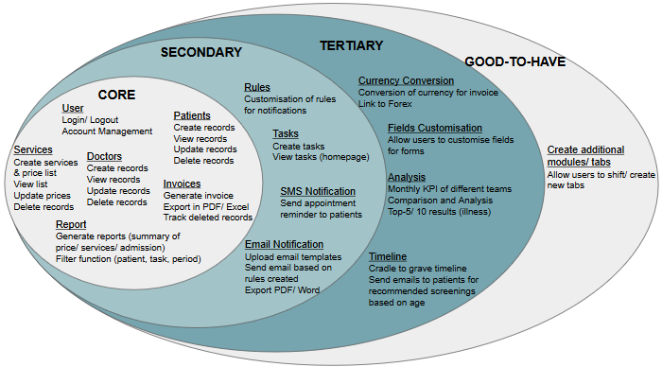

Project Plan

Project milestone:
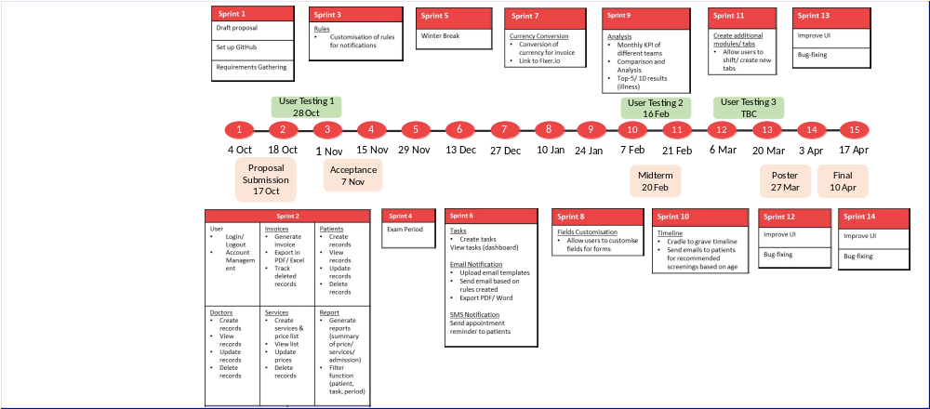

Possible Risks
Category | Description | Impact | Likelihood | Mitigation Steps
Technical | Unfamiliar with coding language like JavaScript & jQuery | May result in delay and bottleneck | Medium | Allocate time to familiarize with the coding language
Management | Allocation of too much/ little time for development of functions | May result in insufficient time for development of functions. | Medium | Include buffer time before final submission. More time is allocated to secondary and tertiary functions
Client | Unable to get hold of database for specific required information (research for timeline) | Timeline will not be accurate without enough information | Medium | Use more generic database (age range instead of specific age)

Resource & reference:
Resource:
- GitHub private repo: distributed and source code management.
- Redhat Openshift Server: Cloud Server
Technology:
- jQuery Ajax, JSP Model 2, Twitter Bootstrap, HTML, Java, JavaScript, MySQL
API:
- Fixer.io (currency conversion)
- Solutions Infini (SMS notification)

